

SRM INSTITUTE OF SCIENCE AND TECHNOLOGY
Kattankulathur, Chengalpattu District - 603203

18CSC304J/ COMPLIER DESIGN
MINI PROJECT REPORT
SYNTAX ANALYSER FOR CONDITIONAL (IF-ELSE STATEMENT)

Guided by:
Mrs.R.Jeya

Assistant Professor Department of Networking And Communications
Submitted By:
Vasu Buchingari (RA2011003010412) Chandra Sekhar K(RA2011003010435)

Aim: -
To design and implement a syntax analyzer for a simple programming language.

ABSTRACT: -
A syntax analyzer, also known as a parser, is a crucial component of a compiler that checks the source code for grammatical correctness and produces a parse tree or abstract syntax tree (AST). The purpose of the syntax analyzer is to analyze the source code's syntax structure, which includes identifying the components of the code and their relationships. The parser accomplishes this by breaking down the code into a sequence of tokens and then using a grammar to verify that the tokens conform tothe language's rules. The syntax analyzer's output is used by the compiler's subsequent stages to generate object code or an executable program. The efficiency and accuracy of the syntax analyzer have a significant impact on the overall quality and performance of the compiler, making it a crucial component of the compilation process.

INTRODUCTION: -

A syntax analyzer for conditional (if-else statement) is a program that checks whether a given input string follows the syntax rules for a valid if-else statement. It takes as input a string representing an if-else statement and checks whether the syntax is correct according to a set of predefined grammar rules.
The analyzer uses a recursive descent parsing technique,where each non-terminal symbol in the grammar is represented by a separate function. These functions worktogether to parse the input string and check for syntax errors.
The program checks for syntax errors such as missing or extra tokens, incorrect use of operators and keywords, and invalid expressions or statements. If the input string passes all the syntax checks, the analyzer returns a message indicating that the syntax is correct. Otherwise, itreturns an error message indicating where the syntax erroroccurred.
Overall, a syntax analyzer for conditional statements helpsensure that code is written correctly and can be interpretedby compilers and other programs that process code.

ADVANTAGES OF SYNTAX ANALYSER: -

- Improved code quality: Syntax analyzers help to ensure that the source code conforms to the grammar rules of the programming language, which helps to improve code quality. By identifying syntax errors early in the development process, syntax analyzers help to reduce the number of errors and bugs in the final application.

- Faster debugging: Syntax analysers can help to speedup the debugging process by quickly identifying syntax errors and pinpointing their location in the code. This can help developers to quickly identify and fix errors, which can save time and improve the overall efficiency of the development process.

- Improved productivity: By providing suggestions and highlighting errors in real-time, syntax analyzers can help to improve the productivity of developers. This can reduce the amount of time spent on manual error detection and correction, allowing developers to focus on other tasks such as writing and testing code.

- Standardization: Syntax analyzers help to enforce standardization in programming languages by ensuring that code conforms to the grammar rules ofthe language. This can help to improve code readability and maintainability, as well as make it easier for other developers to understand and work with the code.

- Better software performance: Syntax analyzers can also help to improve the performance of software applications by ensuring that the code is properly structured and optimized for execution. By identifying potential issues early in the developmentprocess, syntax analyzers can help to prevent performance issues from occurring in the final application.

Overall, syntax analysers provide several advantages in the development and execution of software applications,including improved code quality, faster debugging, improved productivity, standardization, and better software performance.

WORKING OF SYNTAX ANALYSER: -

EXAMPLE 1:-

Suppose we have the following input string if (a == 5) { b = 2; } else { b = 3; }
The syntax analyzer starts by calling the statement function with the input string and a position variable pos initialized to 0. The statement function first checks whether the input string starts with the keyword "if". Since it does, the function consumes the "if" keyword and advances pos to the next position in the input string Next, the function checks whether the next character in the input string is a left parenthesis. It is, so the function consumes the left parenthesis and advances pos again. The expression function is then called to parse the expression inside the parentheses. In this case, the expression is (a == 5), which consists of a variable a, a comparison operator ==, and a value 5. The expression function successfully parses this expression and advances pos to the next position in the input string.
The statement function then checks whether the next character in the input string is a right parenthesis. It is, so the function

consumes the right parenthesis and advances pos again. The function then calls itself recursively to parse the statement inside the if block. In this case, the statement is { b = 2; }. The function calls factor to parse the expression b = 2;, which is successful. The function then advances pos to the next position in the input string, which is the end of the if block.

The statement function then checks whether there is an "else" keyword in the input string. There is, so the function consumes the "else" keyword and advances pos again. The function then calls itself recursively to parse the statement inside the else block. In this case, the statement is { b = 3; }. The function calls factor to parse the expression b = 3;, which is successful. The function then advances pos to the end of the input string.

At this point, the statement function has successfully parsed the entire input string and returns true. The main function then checks whether pos is equal to the length of the input string.
Since it is, the program outputs "Syntax is correct".

EXAMPLE 2:-

Now let's consider an incorrect input string:

‘if (a == 5) { b = 2; } else b = 3; }’

This input string is missing a left curly brace before the expression in the else block. When the syntax analyzer tries to parse this input string, it will fail at the factor function for the else block. The factor function expects to find either a primary expression or a left curly brace, but it finds a variable name b instead. This is an error in the syntax, so the factor function returns false to the statement function. The statement function then returns false to the main function, which outputs "Syntax is incorrect".

Overall, the syntax analyzer helps catch errors in the syntax of conditional statements before they can cause problems in a program. By breaking down the input string into smaller pieces and checking each piece against a set of rules, the analyzer can quickly determine whether the input is valid or not.

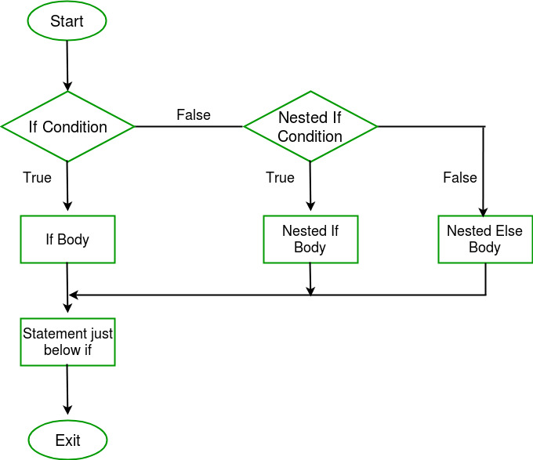

Requirements to run the script:

- C++ language

- Online GDB

STEPS TO BUILD SYNTAX ANALYSER: -

- Choose a programming language to work with. Dependingon the language you choose, the grammar rules and syntaxof if statements may vary. For this project, let's choose the C programming language as an example.

- Define the grammar rules for if statements in the chosen programming language. The grammar rules specify the structure and syntax of an if statement, including the keywords, tokens, and syntax used in the language. For C,the grammar rules for an if statement would include the keywords "if", "else", "(", ")", "{", and "}".

- Implement a lexical analyzer or scanner to read the source code and generate tokens. The scanner breaks the source code into tokens based on the grammar rules of the language. For example, if the source code contains an if statement, the scanner would generate tokens for the "if" keyword, the opening and closing parentheses, the openingand closing braces, and the condition expression.

- Implement a parser to analyze the sequence of tokens and ensure they conform to the grammar rules for if statements.The parser analyzes the tokens generated by the scanner and checks that they are in the correct sequence and formataccording to the grammar rules for if statements. For example, the parser would check that an if statement starts with the "if" keyword followed by an opening parenthesis, that the condition expression is properly formed, and that the statement ends with a closing brace.

- Display any syntax errors to the user. If the parser encounters a syntax error, it should display a message indicating the line number and location of the error, along

with a description of the problem. For example, if the condition expression is missing a closing parenthesis, the parser would report a syntax error indicating that the closing parenthesis is missing.

- Test the syntax analyzer with a variety of sample code to ensure that it correctly identifies errors and parses valid if statements. You can create a test suite that includes samplecode with various errors, as well as correctly formed if statements, to ensure that the syntax analyzer functions correctly.

- Overall, building a syntax analyzer for if statements involves defining the grammar rules for the programming language, implementing a scanner to generate tokens from
the source code, and building a parser to analyze the tokensand ensure they conform to the grammar rules. By testing the syntax analyzer with a variety of sample code, you can ensure that it correctly identifies syntax errors and parses valid if statements.

APPLICATIONS: -

- Compilers: Compilers translate high-level programming languages into machine code that can be executed by a computer. The syntax analyzer is the first step in the compilation process, analyzing the source code to ensure that it conforms to the grammar rules of the language. If there are any syntax errors, the compiler will stop and display an error message, indicating the line number andlocation of the error.

- Interpreters: Interpreters execute source code directly, without the need for compilation. However, they still require a syntax analyzer to analyze the syntax of the source code and ensure that it conforms to the grammarrules of the language. If there are any syntax errors, theinterpreter will stop and display an error message.

- Code editors and IDEs: Integrated development environments (IDEs) and code editors often include syntaxhighlighting and code completion features, which require asyntax analyzer to analyze the source code and provide

suggestions or highlight errors. For example, if a user is typing an if statement, the syntax analyzer can provide suggestions for completing the statement or highlight anysyntax errors.

- Code quality analysis tools: Syntax analyzers can be used as part of code quality analysis tools to identify potential errors or issues in source code. These tools can analyze thesyntax of the code to identify issues such as unused variables, unreachable code, or syntax errors.

Overall, syntax analyzers are a critical component of programming language tools and applications, ensuring that source code is properly structured and conforms to the grammar rules of the language. They are used in compilers,interpreters, code editors and IDEs, and code
quality analysis tools.

Code:
#include <iostream> #include <string> using namespace std;

bool expression(string& input, size_t& pos); bool term(string& input, size_t& pos);
bool factor(string& input, size_t& pos); bool primary(string& input, size_t& pos);

bool expression(string& input, size_t& pos)
{
// Check for a term if (!term(input, pos))
return false;

// Check for zero or more operators and terms while (pos < input.size() &&
(input.substr(pos, 2) == "==" || input.substr(pos, 2) == "!=" || input[pos] == '<' || input[pos] == '>' || input.substr(pos, 2) ==
"<=" ||

input.substr(pos, 2) == ">="))
{
pos += 2; // Consume the operator if (!term(input, pos))
return false;
}

return true;
}

bool term(string& input, size_t& pos)
{
// Check for a factor if (!factor(input, pos))
return false;

// Check for zero or more operators and factors
while (pos < input.size() && (input[pos] == '+' || input[pos] == '-'))
{
++pos; // Consume the operator if (!factor(input, pos))
return false;
}

return true;
}

bool factor(string& input, size_t& pos)
{
// Check for a primary expression if (!primary(input, pos))
return false;

// Check for zero or more operators and primary expressions
while (pos < input.size() && (input[pos] == '*' || input[pos] == '/' || input[pos] == '%'))
{
++pos; // Consume the operator if (!primary(input, pos))
return false;
}

return true;
}

bool primary(string& input, size_t& pos)
{
// Check for an integer literal or variable name

if (pos < input.size() && (isdigit(input[pos]) || isalpha(input[pos])))
{
++pos; // Consume the token return true;
}

// Check for a sub-expression in parentheses if (pos < input.size() && input[pos] == '(')
{
++pos; // Consume the '(' if (!expression(input, pos))
return false;
if (pos >= input.size() || input[pos] != ')') return false; // ')' expected but not found
++pos; // Consume the ')' return true;
}

// Invalid primary expression return false;
}

bool statement(string& input, size_t& pos)
{

// Check for a valid if-else statement if (input.substr(pos, 2) != "if")
return false;
pos += 2; // Consume the 'if' keyword
if (pos >= input.size() || input[pos] != '(') return false;
++pos; // Consume the '(' if (!expression(input, pos))
return false;
if (pos >= input.size() || input[pos] != ')') return false;
++pos; // Consume the ')' if (!statement(input, pos))
return false;
if (pos < input.size() && input.substr(pos, 4) == "else")
{
pos += 4; // Consume the 'else' keyword if (!statement(input, pos))
return false;
}
return true;
}
int main()
{

string input;
cout << "Enter an if-else statement: "; getline(cin, input);
size_t pos = 0;
bool success = statement(input, pos); if (success && pos == input.size()) cout << "Syntax is correct" << endl; else
cout << "Syntax is incorrect" << endl; return 0;
}

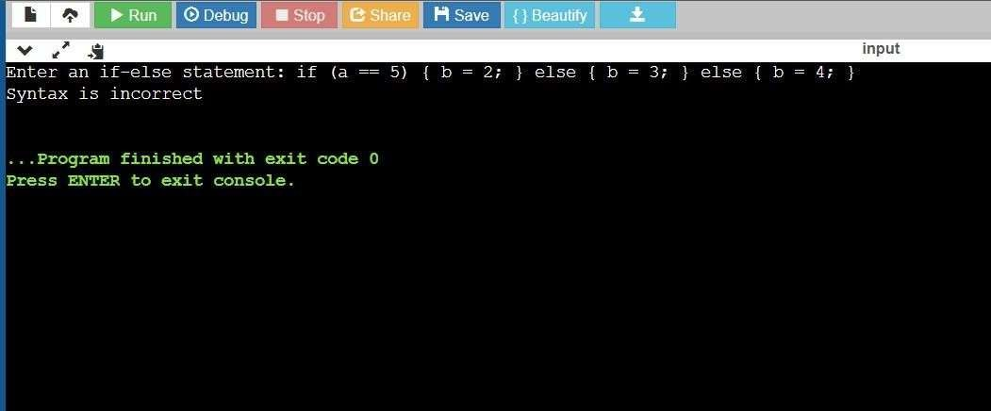

Output:

Result:

Syntax Analyser for Conditional (If-Else Statement) issuccessfully compiled.

